Cover Sheet (L4)
Atlantic Technological University

ASSIGNMENT/REPORT COVER SHEET

Lecturer’s Name: Adam Dunworth / Christopher Crossan
Assessment Title: Automated Liquid Cooling and Leak Detection Prototype for Server Racks
Work to be submitted to:
Date for submission of work: 22nd October 2026
Place and time for submitting work:

To be completed by the Student

Student’s Name: David Roberto Tapia Caicedo
Class: Week 6
Subject/Module: L7 Project
Word Count (where applicable): 4047
I confirm that the work submitted has been produced solely through my own efforts.
Student’s signature: David Date: 18/10/2026

Notes
Penalties: The total marks available for an assessment is reduced by 10% for work submitted up to one week late. The total marks available are reduced by a further 10% for up to two weeks late. Assessment work received more than two weeks late will normally only be considered at the autumn examination board. [Incidents of alleged plagiarism and cheating are dealt with in accordance with the Universities Assessment Regulations.]
Plagiarism: Presenting the ideas etc. of someone else without proper acknowledgement (see section L1 paragraph 8).
Cheating: The use of unauthorised material in a test, exam etc., unauthorised access to test matter, unauthorised collusion, dishonest behaviour in respect of assessments, and deliberate plagiarism (see section L1 paragraph 8).
Continuous Assessment: For students repeating an examination, marks awarded for continuous assessment, shall normally be carried forward from the original examination to the repeat examination.


Automated Liquid Cooling and Leak Detection Prototype for Server Racks
by
David Tapia Caicedo
L00213709
A report submitted in partial fulfilment of the requirements for a
B.Eng (Honours) in Electronic Engineering

Atlantic Technological University

22nd October 2026

Supervised by: Christopher Crossan/Adam Dunworth

Abstract
Server racks generate a lot of heat in a very small space, and keeping them cool without wasting power is a major challenge in modern data centres. Liquid cooling handles high temperatures much better than air alone, but bringing water near electronics introduces an obvious risk of short circuits if a pipe leaks.
This report covers the design and initial testing of a cooling and monitoring prototype based on the Texas Instruments MSP430G2553 microcontroller. The circuit reads room temperature from a TMP36 sensor and relative humidity from an HIH-5030-001 sensor using the microcontroller's 10-bit ADC. Due to memory space issues, all sensor formulas in the code use integer math instead of floating-point numbers. The main operation consists in the MSP430 generating a 1 kHz PWM signal, fed into a DRI0044 dual motor driver. This setup adjusts the voltage sent to a future 5V water pump across three temperature ranges: off below 22 degrees, half power between 22 and 26 degrees, and full power at 26 degrees or higher. Because standard humidity sensors react too slowly to water spills on the floor. A mechanism was also designed using two exposed wire electrodes and a 10 kOhms pull down resistor. At the moment, the dual-channel ADC readings, UART serial output at 9600 baud, and PWM voltage levels have been tested and confirmed on the oscilloscope. The remaining work for this semester involves adding a LCD screen, an ESP8266/ESP32 WiFi module, and testing the physical water loop.

Contents
Introduction 4
Problem Definition 5
Aims and Objectives 6
Aim 6
Objective 6
Design Brief 6
Literature Review 7
Proposed Design and Methodology 7
System Overview 7
Component Selection 9
Methodology 11
Step 1: Multi-Channel ADC Reading and Integer Math 11
Step 2: Hardware-Polled UART Telemetry 11
Step 3: Driver Isolation Check and Oscilloscope PWM Testing 11
Project Plan 14
Risk Assessment and Ethics 15
Progress to Date 16
Next Steps 16
Bibliography 17
Appendices 18
Datasheets 18
Code 20
Pinouts 27
Diagrams 28
Schematics 31

Introduction
As servers become more powerful and packed closer together, air conditioning alone is not enough to keep data centres at safe operating temperatures. Many facilities now rely on liquid cooling loops to pull heat directly away from hardware components. However, it is not optimal for a cooling system to run constantly at 100% power all day. That wastes electricity and wears out the pumps. It needs a control loop that reads the temperature and adjusts the water flow only when necessary. At the same time, the system must watch out for water leaks and condensation. This document presents the first five weeks of work on a data centre cooling and monitoring. Built around the MSP430G2553 LaunchPad, the prototype reads analogue environmental sensors, sends in real time diagnostic data over UART to a PC, and uses Pulse Width Modulation (PWM) to control motor power based on real-time temperature thresholds.

Problem Definition
Running a liquid cooled server rack presents two main problems, energy waste and water damage.
Firstly, a cooling pump that runs at a fixed maximum speed even when the servers are cold, is wasting power and the pump is more likely to fail sooner. Secondly, if a tube breaks or a connector comes loose, water can spill onto live electronics. Relying only on an air humidity sensor like the HIH-5030-001 to catch a leak does not work well in practice. Data centres have strong air conditioning units that dry the air constantly, meaning a puddle can form on the floor long before the room's overall humidity goes up. At the same time, industrial flow meters or commercial leak-sensing cables are very expensive for a small prototype. The goal here is to solve both issues with a low budget using a 16-bit microcontroller. Adjusting pump speed automatically as temperature rises, and catching liquid leaks the exact second water touches the bottom of the tray without running out of microcontroller memory.

Aims and Objectives

Aim
The main goal of this project is to build and test an automated liquid cooling, environmental monitoring, and leak detection prototype for a data centre mock up using the MSP430G2553 microcontroller.

Objective
- Read Multiple Analog Sensors: Connect both the TMP36 temperature sensor and the HIH-5030-001 humidity sensor to the MSP430G2553, switching between ADC channels P1.3 and P1.4 in software without signal cross talk.
- Keep Code Size Small: Write the sensor conversion math in C using only integer arithmetic, so the compiler does not overflow due to float libraries into the microcontroller’s memory.
- Control Motor Speed with PWM: Use Timer_A and a DRI0044 motor driver to run a 5V water pump, and an optional fan on the second channel, at 0%, 50%, and 100% duty cycles depending on the measured temperature.
- Add Direct Water Detection: Build a simple voltage divider leak probe with a 10 kΩ resistor on pin P1.5 to detect water drops in an isolated tray and cut pump power immediately.
- Display and Send Data: Fix UART serial timing at 9600 baud using hardware flags (UCA0TXIFG) for Tera Term logging, later add an LCD screen and Wi-Fi module for cloud monitoring.

Design Brief
The prototype is split into three physical areas for safety: the 3.3V logic side on the LaunchPad, the 5V motor power stage on the DRI0044 driver, and an isolated plastic tray for the possible water tubes leaks. The MSP430G2553 reads room temperature on pin P1.3, air humidity on P1.4, and the leak probe on P1.5. Based on what the sensors read, the C program sets the pump speed. It sends a 1 kHz PWM signal from pin P1.6 and a direction signal from P2.0 into the DRI0044, which then supplies the actual current needed by the motor. While the humidity sensor checks the air for general condensation issues, the two wire probes in the tray act as an emergency switch if water leaks out. Right now, live readings are sent over USB to Tera Term, with an LCD and Wi-Fi connection planned for the second half of the project.

Literature Review
Nowadays server rooms use Computer Room Air Conditioning (CRAC) units to push cold air under raised floors. While air cooling is enough for low power racks, modern high-density servers create local hotspots that air cannot cool down fast enough.
Because water carries heat much better than air, direct liquid cooling loops are now widely used in data centres. However, running a cooling pump at 100% speed all day wastes power and wears out the pump. Commercial cooling units solve this by using Pulse Width Modulation (PWM) to slow the pump down when the servers are cold [6].
Putting water pipes near active electronics brings the high risk of water leaks. In commercial data centres, leaks are usually caught using either special sensing cables on the floor, like Raychem TraceTek, or inline flow meters that compare water going in against water coming out. The problem for this small lab prototype is price: commercial sensing cables and their controllers cost hundreds of euros, and cheap Hall effect flow sensors have too much reading error to spot slow drips reliably.
For low-cost microcontroller projects based on the TI MSP-EXP430G2ET LaunchPad [1], checking room conditions with analogue sensors like the Analog Devices TMP36 [2] and the Honeywell HIH-5030-001 [3] is a common approach. As shown in the TMP36 datasheet, this sensor works from a 2.7 V to 5.5 V supply and gives a linear 10 mV/°C output without needing external calibration circuits [2]. Similarly, the HIH-5030-001 runs down to 2.7 V, making both sensors directly compatible with the 3.3 V logic rail of the MSP430G2553 microcontroller [3], [4]. Still, using only an air humidity sensor to catch a water leak on the floor does not work well in a server room, because the room air conditioning dries the air before vapor reaches the sensor. Combining these ambient sensors with a simple two-wire conductive probe, using a 10 kΩ pull-down resistor on a third ADC pin [8], and a motor driver like the DFRobot DRI0044 [5] lets the circuit control pump speed and catch liquid spills immediately at almost zero cost.

Proposed Design and Methodology

System Overview
For safety during lab testing, the circuit is split into three physical parts: the 3.3 V control logic on the LaunchPad [1], the 5 V motor power stage on the driver board, and a separate plastic drip tray that holds the water tubes and leak probe. The general layout is shown in Fig. 1.
The MSP430G2553 microcontroller [4] reads three analogue voltages one after another using its internal 10-bit ADC (ADC10) multiplexer:
- Pin P1.3 (INCH_3): Connected to the analogue output of the TMP36 temperature sensor [2].
- Pin P1.4 (INCH_4): Connected to the HIH-5030-001 humidity sensor [3].
- Pin P1.5 (INCH_5): Connected to the conductive water leak probe. The water leak probe consists in two bare wire ends placed 2 mm apart in the plastic tray with a 10 kΩ pull-down resistor to GND on the breadboard.
Inside the main C loop, the raw ADC numbers are converted into degrees Celsius and relative humidity percentage using integer math. Live values are sent to a PC terminal in Tera Term at 9600 baud over the hardware UART pins (P1.1 and P1.2), using the isolation block jumper connections on the MSP-EXP430G2ET board [1]. For motor control, Timer_A outputs a 1 kHz PWM signal on pin P1.6 while pin P2.0 sets the rotation direction. These two 3.3 V signals feed into PWM1 and DIR1 on the DRI0044 driver [5], which switches the external 5 V supply (VM) to run the water pump on channel 1 (M1+/M1-) and an optional cooling fan on channel 2 (M2+/M2-).

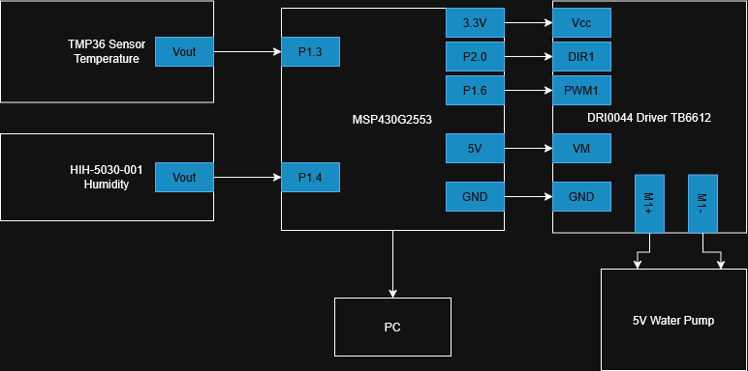
Figure 1: Circuit diagram

Component Selection
Microcontroller MSP430G2553: The main characteristics of this component are its low power consumption, 16-bit RISC architecture, 8-channel 10-bit ADC, hardware UART, and Timer_A PWM outputs [1], [4]. It has enough inputs for the temperature, humidity, and leak sensors. Also generates a 3.3V hardware PWM signal on pin P1.6 without tying up the CPU.
Temperature Sensor (Analogue Devices TMP36): As detailed in its datasheet, the TMP36 operates from a single 2.7 V to 5.5 V supply, requires less than 50 µA of current, and provides a 10 mV/°C scale factor with a 500 mV output at 0°C [2]. This allows direct wiring to the 3.3 V LaunchPad supply and simple conversion in C.
Humidity Sensor (Honeywell HIH-5030-001): This sensor works down to 2.7 V [3], so it shares the same 3.3 V rail as the MSP430G2553 without needing any adjustment.
Motor Driver (DFRobot DRI0044): Its internal MOSFET stage has a much lower voltage drop than older BJT drivers, measuring 4.98 V output from a 5 V supply at 100% duty cycle on the oscilloscope. It also provides a second channel for an auxiliary cooling fan.
Conductive Leak Probe (10 kΩ Pull-Down Resistor and Wire Electrodes): A 10 kΩ resistor holds pin P1.5 at 0 V when the plastic tray is dry. When water touches both wire tips, fluid conductivity completes the circuit to 3.3 V, pulling the ADC voltage up immediately.

A summary of the parts and costs is given in Table 1.
Table 1 – Component List
Item | Quantity | Description | Average Price
MSP-EXP430G2ET | 1 | TI LaunchPad development board with MSP430G2553 [1], [4] | 12.50€
TMP36GT9Z | 1 | Analog Devices low-voltage temperature sensor (TO-92) [2] | 1.80€
HIH-5030-001 | 1 | Honeywell low-voltage relative humidity sensor (SIP-3) [3] | 9.50€
DRI0044 Driver | 1 | DFRobot 2x1.2A DC motor driver (TB6612FNG) [5] | 6.90€
5V Water Pump | 1 | Mini DC 3V–5V submersible cooling pump | 3.50€
5V Cooling Fan | 1 | 40x40mm 5V DC brushless axial fan | 2.50€
Leak Probe | 1 | 10 kΩ pull-down resistor + 2 exposed wire electrodes | 0.20€
16x2 LCD | 1 | HD44780 character display | 4.50€
ESP8266 Module | 1 | Serial Wi-Fi transceiver board | 4.00€

Methodology
The prototype was built and tested in three separate steps so that any wiring mistake on the 5 V motor side would not damage the 3.3 V MSP430G2553 LaunchPad [1].

Step 1: Multi-Channel ADC Reading and Integer Math
The TMP36 temperature sensor was wired to P1.3 (INCH_3) and the HIH-5030-001 humidity sensor to P1.4 (INCH_4). Because the MSP430G2553 uses a single internal sample-and-hold capacitor for its 10-bit ADC, switching channels too quickly caused the humidity pin to copy the temperature voltage when P1.4 was initially left floating. To fix this problem, a change in the Read_ADC function was written. It disables the ADC, selects the new input channel, and waits 16 clock cycles before starting conversion [7].
Instead of using float variables, which quickly overflowed the MSP430G2553 memory, sensor voltages are converted using 32-bit long integer math. For the TMP36 (500 mV offset, 10 mV/°C scale [2]), temperature is calculated from the raw 0–1023 ADC value (adc_t) with a 3.3 V reference:
$${\text{Temperature (}}^{∘}\text{C)}=\frac{\left(\text{adc_t}×330\right)/1024-50}{1}$$
For the HIH-5030-001, applying its 3.3 V transfer function [3] in fixed-point integer math gives:
$$\text{RH (\%)}=\frac{\left(\text{adc_h}-155\right)×10}{65}$$

Step 2: Hardware-Polled UART Telemetry
Live values are sent to Tera Term at 9600 baud via P1.1 and P1.2 [1]. At first, using fixed software delays (__delay_cycles(1000)) cut off the second digit of the numbers because 9600 baud take about 1042 µs per character. This was solved by polling the hardware transmit flag before loading each byte into the transmit buffer (UCA0TXBUF).

Step 3: Driver Isolation Check and Oscilloscope PWM Testing
Before wiring the DFRobot DRI0044 driver [5], a cold continuity test was done with a multimeter across VM, VCC, and GND, reading Open Loop (OL) to confirm there were no internal short circuits. Timer_A was set to Up-Mode at 1 MHz SMCLK to output a 1 kHz PWM wave on P1.6 (TA0.1). Heating the TMP36 sensor by hand changed TACCR1 across three levels. The results measured on the oscilloscope across the motor outputs (M1+/M1-) and logic pin P1.6 are shown in Figs. 2, 3, 4 and Table 2.

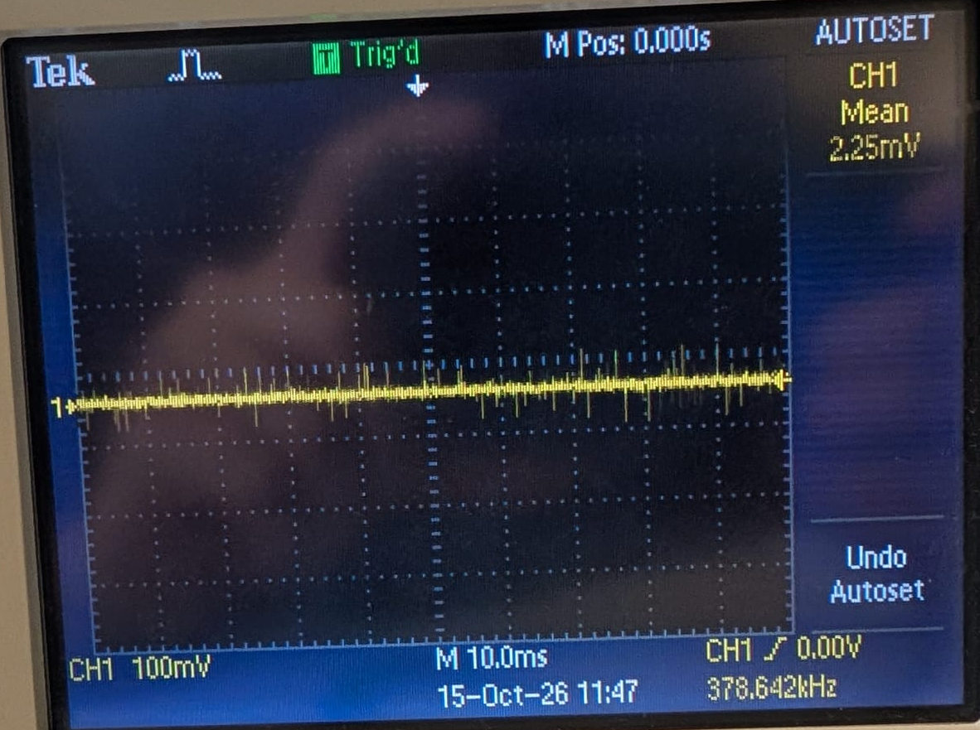
Figure 2: M1+/M1- below 22ºC
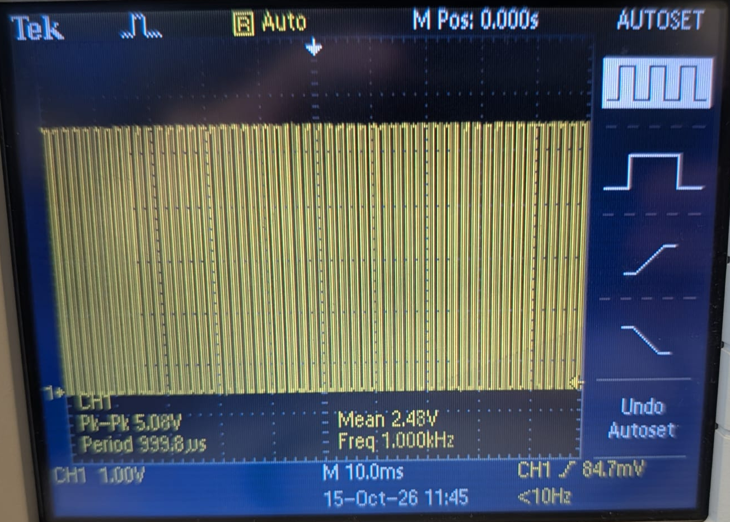
Figure 3: M1+/M1- between 22ºC and 26ºC
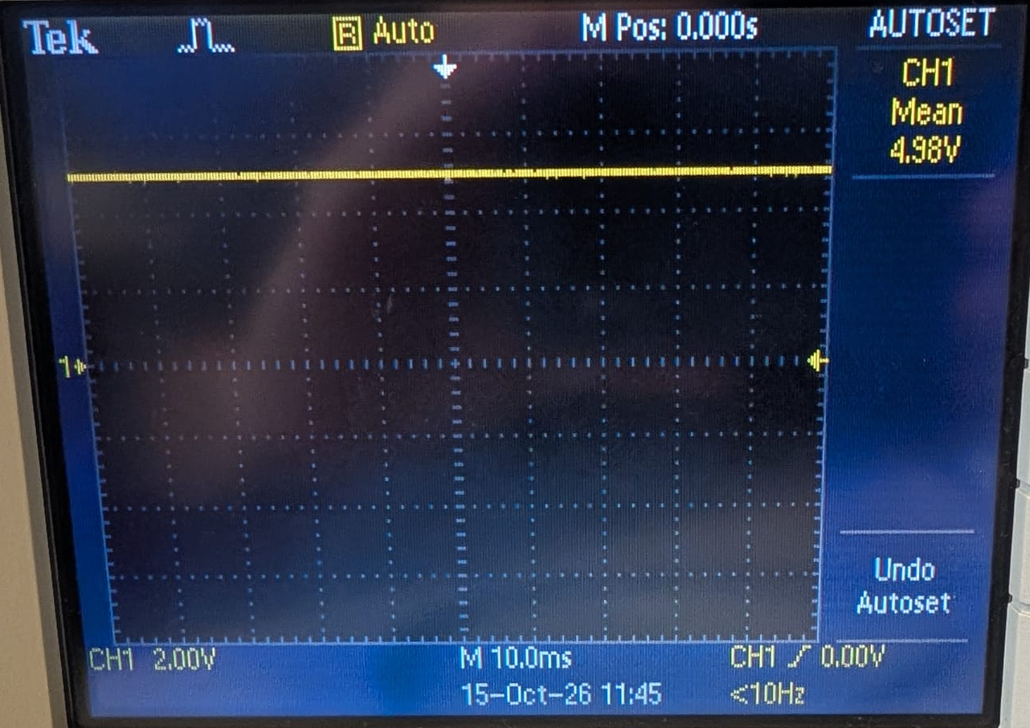
Figure 4: M1+/M1- above 26ºC

Table 2 – Oscilloscope PWM Validation Results
Thermal Range | Duty Cycle (TACCR1) | Logic Pin P1.6 (PWM1) | Driver Output (M1+ to M1-) | Observed Waveform
< 22°C | 0% | 0 V | 2.25 mV | Flat DC line
22°C – 25°C | 50% | 3.3 Vpp (1 kHz) | 2.48 V | 1 kHz square wave
$≥$ 26°C | 100% | 3.3 V DC | 4.98 V DC | Flat DC line

Project Plan
The project is divided into a 12-week schedule covering hardware testing, C programming, peripheral expansion, and final enclosure assembly. Tasks from Week 1 to Week 5 are complete, and the remaining weeks focus on the leak detector, LCD display, Wi-Fi link, and closed loop water testing, as shown in Table 3.

Table 3 – Project Timeline
Task | W1-W2 | W3 | W4 | W5 | W6 | W7-W8 | W9-W10 | W11-W12 | STATUS
Project research |  |  |  |  |  |  |  |  | Complete
Component research & pinout study |  |  |  |  |  |  |  |  | Complete
TMP36 ADC & UART 9600 baud setup |  |  |  |  |  |  |  |  | Complete
Timer_A PWM & driver troubleshooting |  |  |  |  |  |  |  |  | Complete
HIH-5030 ADC, UART fix & scope test |  |  |  |  |  |  |  |  | Complete
Interim Report submission |  |  |  |  |  |  |  |  | Complete
Leak probe & emergency stop |  |  |  |  |  |  |  |  | To do
LCD screen wiring & driver code |  |  |  |  |  |  |  |  | To do
ESP8266 Wi-Fi cloud telemetry setup |  |  |  |  |  |  |  |  | To do
Full water loop, fan & final testing |  |  |  |  |  |  |  |  | To do

Risk Assessment and Ethics
Technical and Lab Safety Risks
Working with water next to an active breadboard and a laptop USB port is the biggest safety hazard in this lab setup, since a single drop could easily short-circuit the LaunchPad or the computer. To avoid this, the water pump, the tubing, and the bare wire tips of the leak probe are all kept inside a separate plastic tray away from the electronics, using 20 cm jumper wires to connect back to the dry breadboard. Another hardware issue we already ran into was burning out an earlier motor driver during the first’s tests. Because DC motors can draw high startup currents and generate back-EMF voltage spikes when stopping, the replacement DRI0044 board was checked for internal shorts with a multimeter before powering it up, and its 5 V motor supply (VM) is kept separate from the 3.3 V microcontroller rail (VCC). Finally, on the software side, MSP430G2553’s memory overflow is a minor risk as the project grows, which was sorted out early on by sticking to integer math so there is enough memory left for the LCD and Wi-Fi code.
Regarding ethics and environmental rules, the circuit only reads room temperature and humidity, meaning no personal data is collected. The main goal of the prototype is to reduce power waste in server racks by using PWM to slow down the cooling pump when the hardware is cold, instead of running motors at full speed all day. All components used in the lab are RoHS compliant, which establish that a product mustn’t exceed safe limits for 10 toxic materials.

Progress to Date
- Wired and tested both the TMP36 (P1.3) and HIH-5030-001 (P1.4) sensors on the 3.3 V LaunchPad supply [1], [2], [3].
- Wrote a multi-channel Read_ADC() function in C with a 16-cycle sample-and-hold delay (ADC10SHT_2), fixing the floating-pin crosstalk issue between temperature and humidity readings.
- Replaced fixed UART delays with hardware flag polling (UCA0TXIFG), getting clean serial output on Tera Term at 9600 baud.
- Checked the replacement DRI0044 motor driver [5] with a multimeter and verified the 1 kHz PWM waveforms, P1.6 and M1+/M1-, on the oscilloscope across all three temperature thresholds: <22°C, 22°C–25°C, and $≥$26°C.

Next Steps

- Week 6: Wire the 10 kΩ pull-down leak detection probe to pin P1.5 and add an if condition in C that forces the pump to shut off and prints a warning when water touches the wire tips.
- Weeks 7–8: Connect an LCD in 4-bit mode to display temperature, humidity, and leak status without needing a PC connected.
- Weeks 9–10: Interface an ESP8266 Wi-Fi module over serial to send live readings to a web dashboard.
- Weeks 11–12: Connect the physical 5 V submersible water pump to channel 1 (M1+/M1-) and the 5 V cooling fan to channel 2 (M2+/M2-) of the DRI0044 for full closed-loop thermal testing.

Bibliography
- [1] Texas Instruments, MSP-EXP430G2ET LaunchPad Development Kit User's Guide, SLAU772A, Jul. 2018.
- [2] Analog Devices, Low Voltage Temperature Sensors TMP35/TMP36/TMP37 Data Sheet, Rev. H, May 2015.
- [3] Honeywell, HIH-5030/5031 Series Low Voltage Humidity Sensors Datasheet, 009042-2-EN, Mar. 2010.
- [4] Texas Instruments, MSP430G2x53, MSP430G2x13 Mixed Signal Microcontroller Datasheet, SLAS735J, May 2013.
- [5] DFRobot, 2x1.2A DC Motor Driver (TB6612FNG) SKU: DRI0044 Wiki & Specifications, 2017.
- [6] Joyplanes, "How PWM works | Controlling a DC motor with a homemade circuit," YouTube, Feb. 5, 2019. [Online]. Available: http://www.youtube.com/watch?v=5nwNKPs2gco
- [7] Jocatronix, "04 Como funciona un ADC de aproximaciones sucesivas," YouTube, Mar. 30, 2023. [Online]. Available: http://www.youtube.com/watch?v=IoQ9Gj3lBvE
- [8] Texas Instruments, "Leak Detection, Flow, and Pressure Monitoring in Liquid Cooling Systems," Application Note SNAA422, 2024. [Online]. Available: https://www.ti.com/lit/pdf/snaa422

Appendices

Datasheets
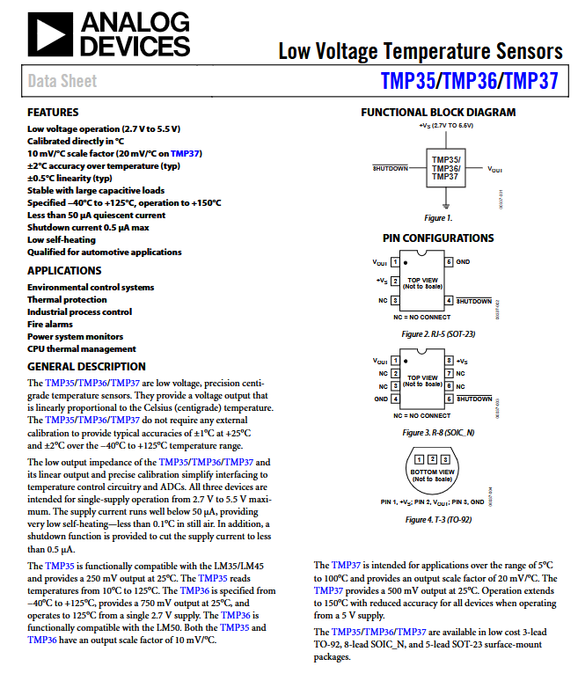
Figure 5: TMP36 Datasheet
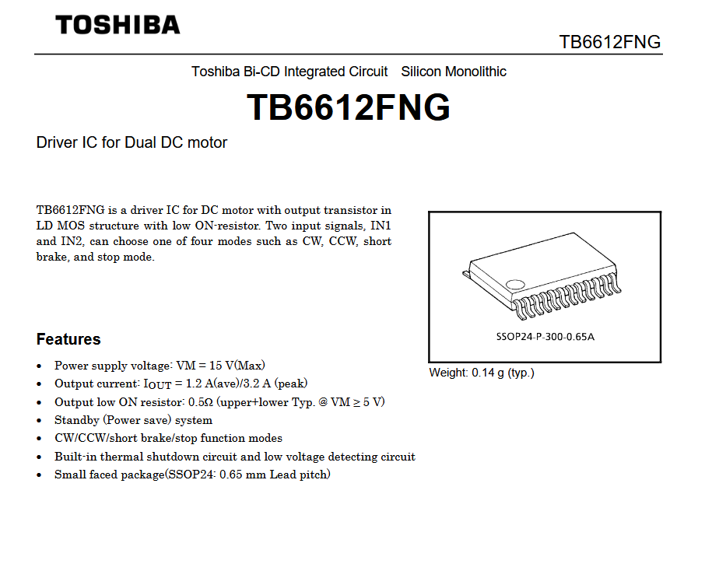
Figure 6: TB6612FNG datasheet
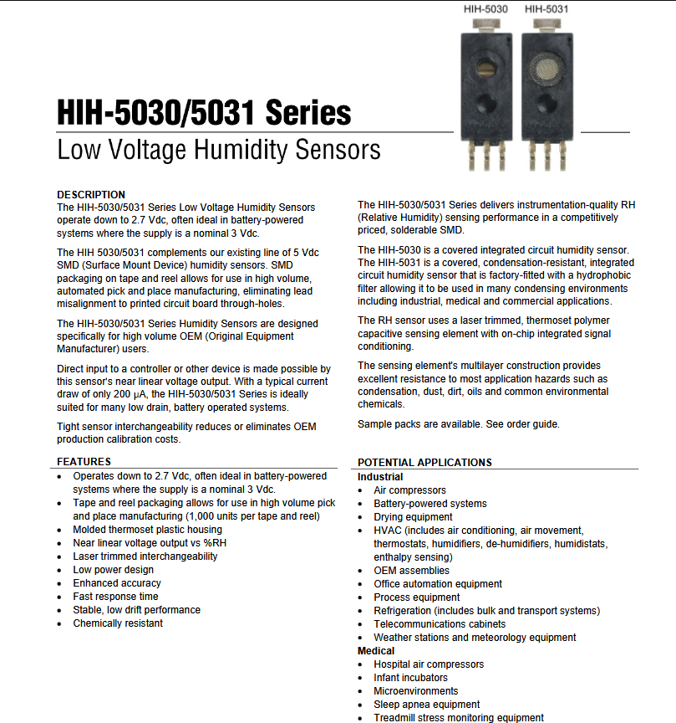
Figure 7: HIH-5030/5031 datasheet

Code
#include <msp430.h>

#define TXLED BIT0
#define RXLED BIT6
#define TXD BIT2
#define RXD BIT1

void SendData(char *dat);
unsigned int Read_ADC(unsigned int canal);
void UART_OutUDec(unsigned int n);
int Temperature_value(int ADC_Value);
int Humidity_value(unsigned int ADC_Value);
void Init_Motor_PWM(void);
int temp_C = 0;

char CRLF[] = { 0x0a, 0x0d, 0x00 };
unsigned int ADC_Value;

int main(void)
{
WDTCTL = WDTPW + WDTHOLD;

int tmp;

DCOCTL = 0;
BCSCTL1 = CALBC1_1MHZ;
DCOCTL = CALDCO_1MHZ;

P2DIR |= 0xFF;
P2OUT &= 0x00;

P1SEL |= RXD + TXD;
P1SEL2 |= RXD + TXD;
P1DIR |= RXLED + TXLED;
P1OUT &= 0x00;

UCA0CTL1 |= UCSSEL_2;
UCA0BR0 = 104;
UCA0BR1 = 0x00;
UCA0MCTL = UCBRS2 + UCBRS0;
UCA0CTL1 &= ~UCSWRST;

// Initiate the motor
Init_Motor_PWM();

while (1)
{
// Read temperature on Pin P1.3
unsigned int adc_temp = Read_ADC(3);
tmp = Temperature_value(adc_temp);

// Read humidity on Pin P1.4
unsigned int adc_hum = Read_ADC(4);
int hum = Humidity_value(adc_hum);

// Send data to Tera Term
SendData("Temp: ");
UART_OutUDec(tmp);
SendData(" C Humidity: ");
UART_OutUDec(hum);
SendData("%");
SendData(CRLF); // Space jump

// Motor management , remains the same
if (tmp < 22)
{
TACCR1 = 0;
}
else if (tmp >= 22 && tmp < 26)
{
TACCR1 = 500;
}
else if (tmp >= 26)
{
TACCR1 = 1000;
}

__delay_cycles(1000000); // wait 1 sec
}
}

int Temperature_value(int ADC_Value)
{
long Vout = (ADC_Value * 3300) / 1023; // Voltage out will be in mV
int tmp = (Vout - 500) / 10; //Apply offset and divide 10mV/°C
return tmp;
}

void SendData(char *dat)
{
unsigned int j = 0;
while (dat[j] != 0x00)
{
// Polling asking for a free transmission buffer
while (!(IFG2 & UCA0TXIFG));

UCA0TXBUF = (dat[j]);
j++;
}
}

void UART_OutUDec(unsigned int n)
{
if (n >= 10)
{
UART_OutUDec(n / 10);
n = n % 10;
}

// Polling asking for a free transmission buffer
while (!(IFG2 & UCA0TXIFG));

UCA0TXBUF = (n + 0x30);
}

unsigned int Read_ADC(unsigned int canal)
{
ADC10CTL0 &= ~ENC; // Turn off temporarily the conversion to change the pin

if (canal == 3)
{
ADC10CTL1 = INCH_3 + ADC10SSEL_3; // Configure channel A3 (Pin 1.3 - Temperature)
ADC10AE0 |= BIT3;
}
else if (canal == 4)
{
ADC10CTL1 = INCH_4 + ADC10SSEL_3; // Configure for channel A4 (Pin 1.4, humidity)
ADC10AE0 |= BIT4;
}

ADC10CTL0 = ADC10ON + ENC; // Turn on
ADC10CTL0 |= ADC10SC; // Start conversion

while (ADC10CTL1 & ADC10BUSY)
{
// wait until its done
}

return ADC10MEM; // Return the value measured
}

// Function to read humidity in human values
int Humidity_value(unsigned int ADC_Value)
{
// Formula in integers based in the datasheet
int rh = ((ADC_Value - 155) * 10) / 65;

// Security limits in case of noise
if (rh < 0)
rh = 0;
if (rh > 100)
rh = 100;

return rh;
}

void Init_Motor_PWM(void)
{
// Configure direction pins (AIN1 y AIN2)
P2DIR |= BIT0 + BIT2; // P2.0 y P2.2 as outputs
P2OUT &= ~(BIT0 + BIT2); // Start with the motor off (LOW)

// Configure el speed pin (PWMA) in P1.6
P1DIR |= BIT6; // P1.6 as output
P1SEL |= BIT6; // P1.6 connected to Timer_A

// Configure Timer_A to generate PWM wave
TACCR0 = 1000 - 1;// Period of the wave (TACCR0) -> 1000 cycles (1 kHz)

TACCR1 = 500; // Initial work cycle (TACCR1) -> 500 cycles (50% speed)

TACCTL1 = OUTMOD_7; // Output mode: Reset/Set, generates the PWM pulse

TACTL = TASSEL_2 + MC_1; // Turn on the Timer: SMCLK (1MHz), Mode Up (cuenta hasta TACCR0)
}

Pinouts
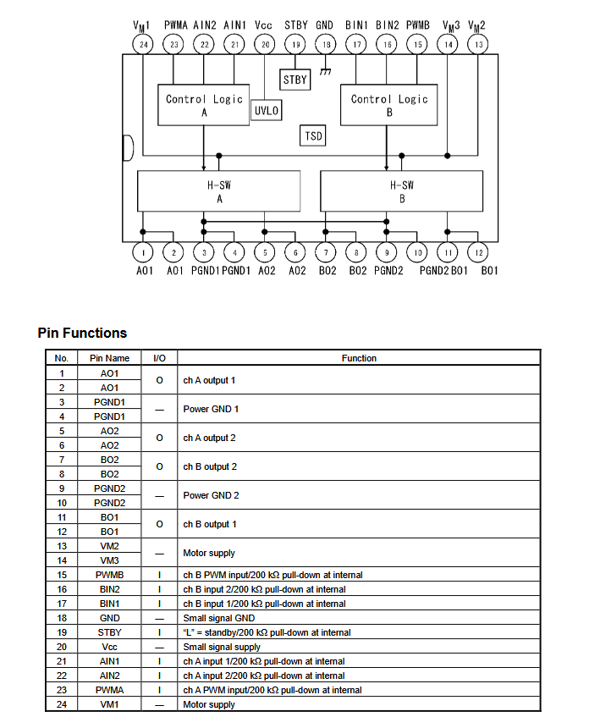
Figure 8: Pinouts of TB6612FNG motor driver

Figure 9: Pinouts of HIH-5030/5031 humidity sensor
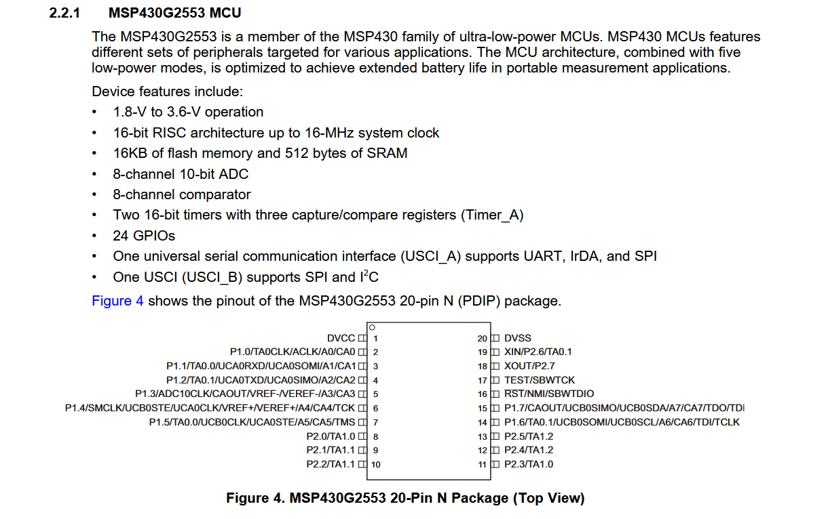
Figure 10: Pinouts of MSP430G2553
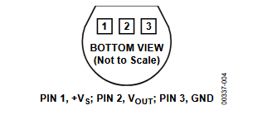
Figure 11: Pinouts of TMP36

Diagrams

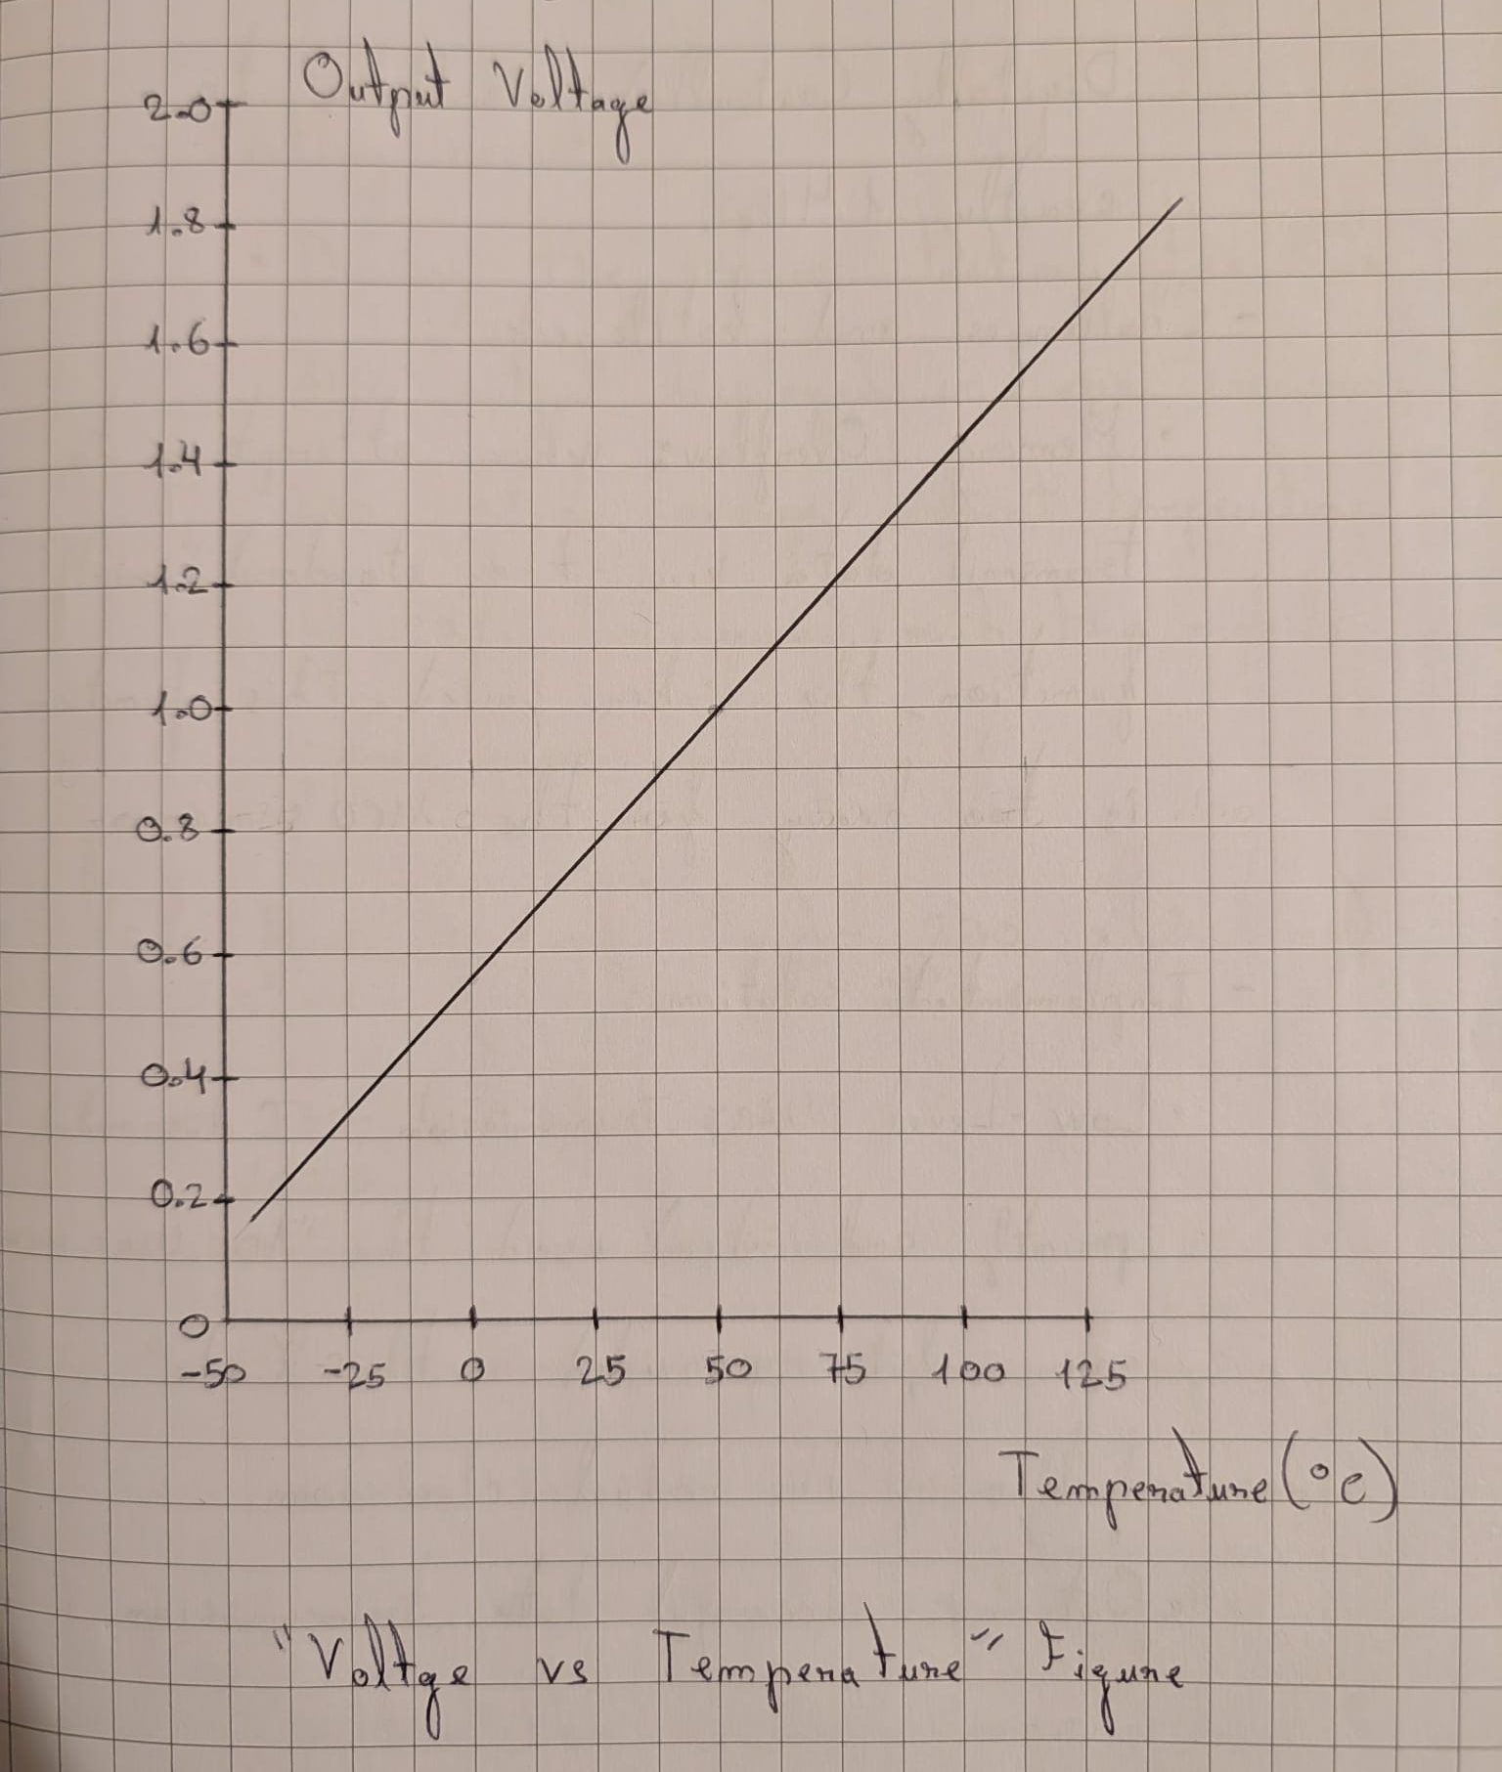
Figure 12: Voltage vs Temperature Figure from TMP36

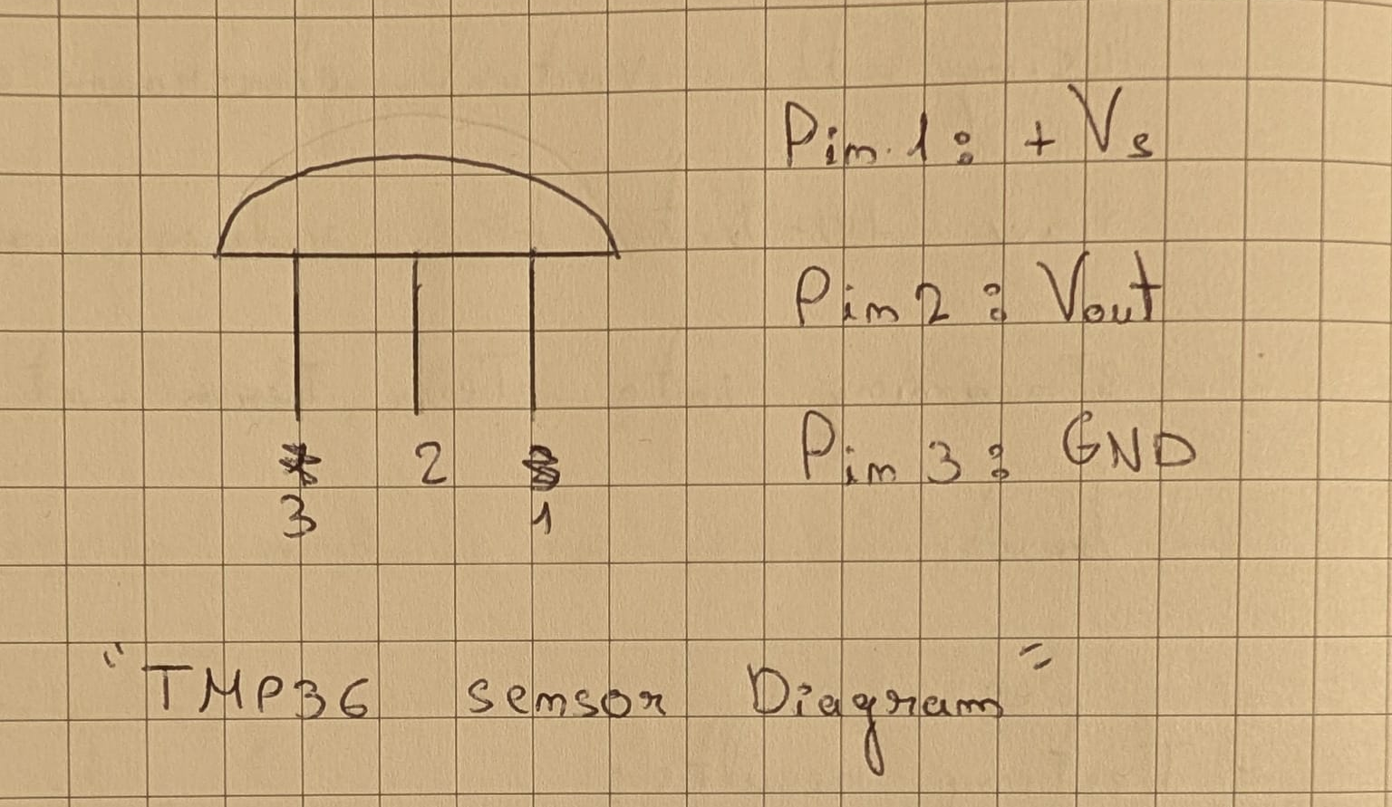
Figure 13: TMP36 Pinouts diagram

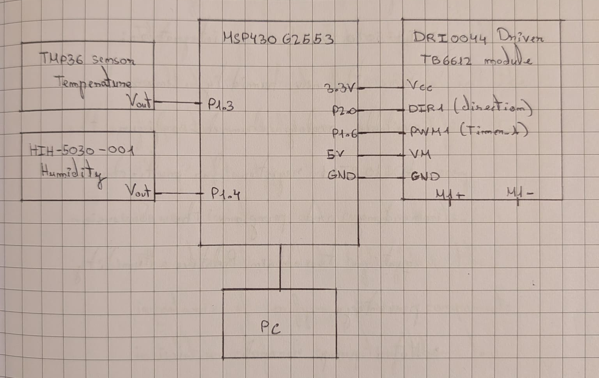
Figure 14: Diagram of the current components

Schematics

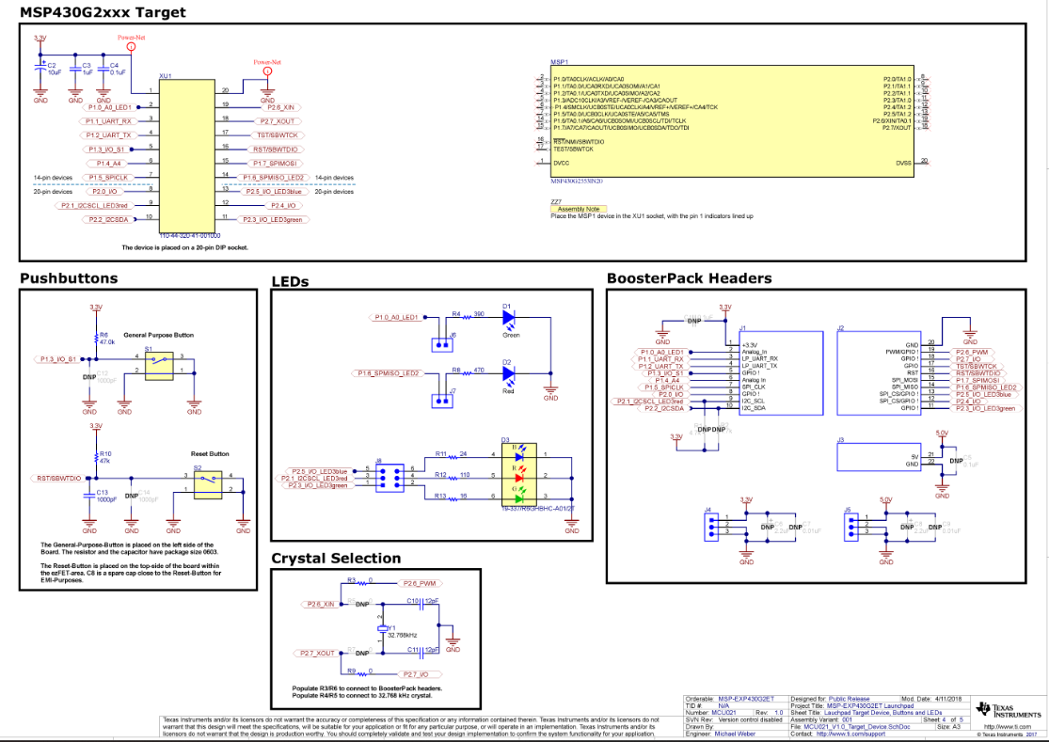
Figure 15: MSP-EXP430G2ET Schematic
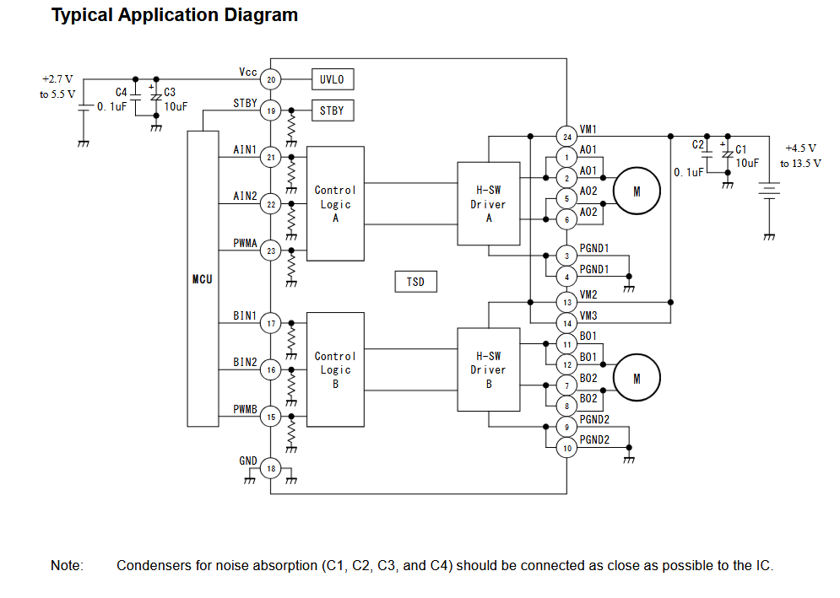
Figure 16: TB6612FNG Schematic

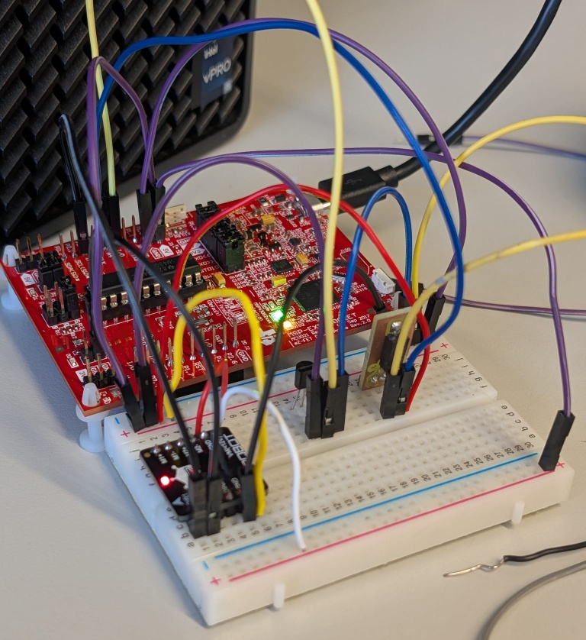
Figure 17: Circuit mounted

